Analytics in Microsoft Intelligent Data Platform
DREAM Demo in a Box
Setup Document
For demo feedback and other questions please email dreamdemos@microsoft.com
For demo environment issues, please email dreamdemossupport@spektrasystems.com
DREAM demos for Microsoft sellers at https://aka.ms/dreamdemos.
DREAM Demos and DDiB assets for partners in MPN Portal at https://aka.ms/dreamdemosforpartners

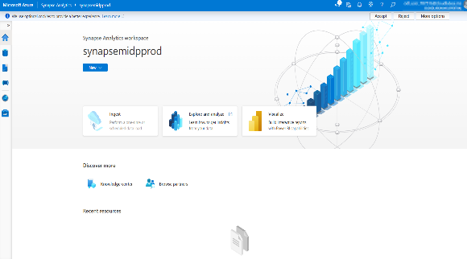
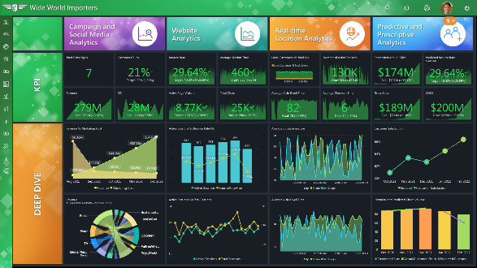
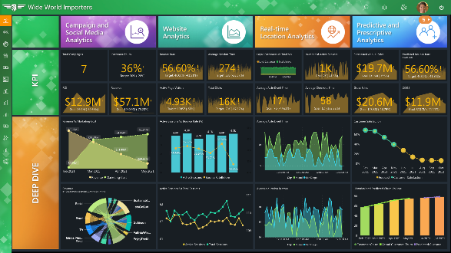
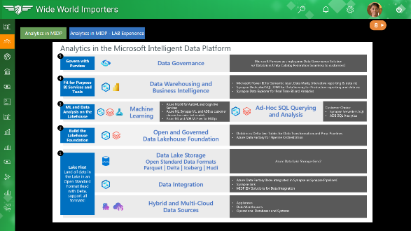
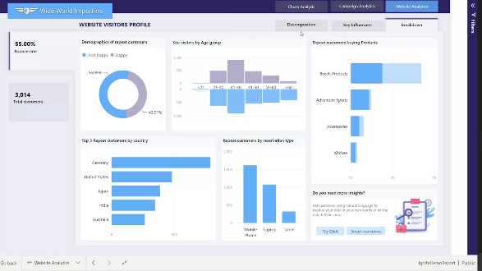
IMPORTANT NOTES:
- DREAM Demo in a Box (DDiB) can be deployed by sellers in their Azure Subscriptions. Sellers can deploy DDiB in customers’ subscriptions ONLY through the CAPE process. CAPE tool is accessible by Microsoft employees. For more information about the CAPE process, please connect with your Local Data & AI Specialist or CSA/GBB.
- Please go through the license agreement before proceeding. Please follow the agreements and disclaimers included with the assets.
- Please note that Azure hosting costs are involved when DREAM Demos in a Box are implemented in customer or partner Azure subscriptions. Microsoft will not cover DDiB hosting costs for sellers or customers.
- Since this is a DDiB, there are certain resources open to the public. Please ensure proper security practices are followed before you add any sensitive data into the environment. To strengthen the security posture of the environment, leverage Azure Security Center.
- For any questions or comments please email dreamdemos@microsoft.com.

NOTE: Set up your demo environment at least two hours before your scheduled demo to make sure everything is working.

The Basics
Steps | Screenshot
PLEASE USE Microsoft EDGE based on CHROMIUM for the below steps to enable copying and pasting credentials directly from the browser. There is a known issue with the Edge browser where the copy/paste for credentials doesn’t work. To download Microsoft Edge based on Chromium, please go here.
The screenshots in this document are from the writer's demo environment. The demo resources for readers or presenters (like Azure Synapse Analytics, Power BI workspace, and SQL endpoints) may have different names than these screenshots. We advise readers to use their judgment to select the correct demo resources.
Requirements
- An Azure account with the ability to create an Azure Synapse Workspace.
- A Power BI Pro or Premium account to host Power BI reports.
- Make sure you are the Power BI administrator for your account and Service principal access is enabled on your Power BI tenant.
- Make sure the following resource providers are registered in your subscription.
- Microsoft.Sql
- Microsoft.Synapse
- Microsoft.StreamAnalytics
- Microsoft.EventHub
- Microsoft.Media.MediaServices
- Microsoft.Kusto
- Microsoft.Purview
- You can run only one deployment at any point in time and need to wait for its completion. You should not run multiple deployments in parallel as that will cause deployment failures.
- Select a region where the desired Azure Services are available. If certain services are not available, deployment may fail. See Azure Services Global Availability for understanding target service availability. (Consider the region availability for Synapse workspace and cognitive services while choosing a location)
- Do not use any special characters or uppercase letters in the environment code. Also, do not re-use your environment code.
- In this DDiB we have converted real-time reports into static reports for the ease of users but have covered the entire process to configure a real-time dataset. Using those real-time datasets, you can create real-time reports.
- Please ensure that you select the correct resource group name. We have given a sample name that may need to be changed should any resource group with the same name already exist in your subscription.
- The audience for this document is CSA’s/GBB’s.
- Please log in to Azure and Power BI using the same credentials.
- Once the resources have been set up, please ensure that your AD user, Synapse workspace and AD application called “midp” have the “Storage Blob Data Owner” role assigned on the storage account name starting with “storage”. You need to contact AD admin to get this done.

Guidelines and Best Practices for Delivery Leads
Do​  - Work with the customer to monitor the daily costs of resources, especially SQL Pools to help minimize costs​.  - Pause the resources when not in use by following Task 10: Pause/Resume resources. Not doing so could result in an unexpected cost to the customer.  - The delivery lead from Microsoft should work with the subscription owner/customer to do the cleanup​.  - Follow the naming conventions for the resources that are mentioned in the DDiB setup document​. ​  - Follow the standard POC process that CSAs/GBBs/Engineering teams use​.  - Secure resources & Power BI within the customer’s VPN.​​  - Use a dev or test environment for deployment. ​  - Follow Azure security best practices and patterns​​.  - Ensure that the Power BI workspace meets the customer’s security and compliance policies​. | Don’t  - CSAs, GBBs, or partners - Do NOT include any customer confidential data.  - Do not leave SQL pools running when not in use​.  - Do not modify the table schemas when customizing the customer’s data as pipelines and Power BI reports will fail​.  - Do not keep your Azure Cloud Shell idle for more than 10 minutes to avoid the Cloud Shell timeout error. ​  - Do not share the following credentials with anyone outside the delivery team: ​  -SQL and Shared Access Signature (SAS) ​  -Web app/Power BI workspace credentials​  - Do not assign resource permissions to anyone outside the delivery team.

Set-up Tasks

Follow the set-up instructions mentioned here on GitHub.
Appendix: Known Security Vulnerabilities

Appendix – Known Security Vulnerabilities
Sr. | Resource | Severity | Risk | Comments
1. | Synapse SQL Pool  - Single deployed Synapse SQL Pool | High | The shared user is used for deployments and access | This is necessary for hydrating the data in advance. Users can later be restricted access based on requirements.
2. | Storage Accounts  - Storage Account with prefix dreamdemogen2 | High | Few of the containers are public | This is done for ease of access during the POC deployment.
3. | Azure Synapse Workspace  - Single deployed Synapse Workspace | High | All IP Addresses Open | Need this open to preload data. Access can later be restricted by users, by allowing their IPs and restricting others.

DISCLAIMER
This presentation, demonstration, and demonstration model are for informational purposes only and (1) are not subject to SOC 1 and SOC 2 compliance audits, and (2) are not designed, intended, or made available as a medical device(s) or as a substitute for professional medical advice, diagnosis, treatment or judgment. Microsoft makes no warranties, express or implied, in this presentation, demonstration, and demonstration model. Nothing in this presentation, demonstration, or demonstration model modifies any of the terms and conditions of Microsoft’s written and signed agreements. This is not an offer and applicable terms and the information provided is subject to revision and may be changed at any time by Microsoft.

This presentation, demonstration, and demonstration model do not give you or your organization any license to any patents, trademarks, copyrights, or other intellectual property covering the subject matter in this presentation, demonstration, and demonstration model.

The information contained in this presentation, demonstration, and demonstration model represents the current view of Microsoft on the issues discussed as of the date of presentation and/or demonstration, for the duration of your access to the demonstration model. Because Microsoft must respond to changing market conditions, it should not be interpreted to be a commitment on the part of Microsoft, and Microsoft cannot guarantee the accuracy of any information presented after the date of presentation and/or demonstration and for the duration of your access to the demonstration model.

No Microsoft technology, nor any of its component technologies, including the demonstration model, is intended or made available as a substitute for the professional advice, opinion, or judgment of (1) certified financial services professional, or (2) a certified medical professional. Partners or customers are responsible for ensuring the regulatory compliance of any solution they build using Microsoft technologies.

© 2021 Microsoft Corporation. All rights reserved.

By using this demo/lab, you agree to the following terms:
The technology/functionality described in this demo/lab is provided by Microsoft Corporation to obtain your feedback and provide you with a learning experience. You may only use the demo/lab to evaluate such technology features and functionality and provide feedback to Microsoft. You may not use it for any other purpose. You may not modify, copy, distribute, transmit, display, perform, reproduce, publish, license, create derivative works from, transfer, or sell this demo/lab or any portion thereof.
COPYING OR REPRODUCTION OF THE DEMO/LAB (OR ANY PORTION OF IT) TO ANY OTHER SERVER OR LOCATION FOR FURTHER REPRODUCTION OR REDISTRIBUTION IS EXPRESSLY PROHIBITED.
THIS DEMO/LAB PROVIDES CERTAIN SOFTWARE TECHNOLOGY/PRODUCT FEATURES AND FUNCTIONALITY, INCLUDING POTENTIAL NEW FEATURES AND CONCEPTS, IN A SIMULATED ENVIRONMENT WITHOUT A COMPLEX SET-UP OR INSTALLATION FOR THE PURPOSE DESCRIBED ABOVE. THE TECHNOLOGY/CONCEPTS REPRESENTED IN THIS DEMO/LAB MAY NOT REPRESENT FULL FEATURE FUNCTIONALITY AND MAY NOT WORK THE WAY A FINAL VERSION MAY WORK. WE ALSO MAY NOT RELEASE A FINAL VERSION OF SUCH FEATURES OR CONCEPTS. YOUR EXPERIENCE WITH USING SUCH FEATURES AND FUNCTIONALITY IN A PHYSICAL ENVIRONMENT MAY ALSO BE DIFFERENT.
FEEDBACK. If you give feedback about the technology features, functionality, and/or concepts described in this demo/lab to Microsoft, you give Microsoft, without charge, the right to use, share and commercialize your feedback in any way and for any purpose. You also give to third parties, without charge, any patent rights needed for their products, technologies, and services to use or interface with any specific parts of a Microsoft software or service that includes the feedback. You may not give feedback that is subject to a license that requires Microsoft to license its software or documentation to third parties because we include your feedback in them. These rights survive this agreement.
MICROSOFT CORPORATION HEREBY DISCLAIMS ALL WARRANTIES AND CONDITIONS WITH REGARD TO THE DEMO/LAB, INCLUDING ALL WARRANTIES AND CONDITIONS OF MERCHANTABILITY, WHETHER EXPRESS, IMPLIED, OR STATUTORY, FITNESS FOR A PARTICULAR PURPOSE, TITLE, AND NON-INFRINGEMENT. MICROSOFT DOES NOT MAKE ANY ASSURANCES OR REPRESENTATIONS CONCERNING THE ACCURACY OF THE RESULTS, OUTPUT THAT DERIVES FROM THE USE OF DEMO/ LAB, OR SUITABILITY OF THE INFORMATION CONTAINED IN THE DEMO/LAB FOR ANY PURPOSE.

